Traffic and Weather Data Analysis for Smart Travel Suggestion
Dr. M. Ayyadurai, Dr. G. Dharani Devi*, S. Thanikaivel, M. Thaneshwar and M. Vaishnavi
Department of Computer Science and Engineering, Rajalakshmi Engineering College, Chennai, India
Abstract: Traffic overload is a major problem, especially in urban regions. Changes in the weather and heavy traffic have a large impact on the flow of vehicles. This work analyzes traffic and weather data in different locations to study how weather and locality affect the flow of traffic. Data is collected and preprocessed, and weather-related features are combined with traffic datasets to identify meaningful patterns. By using machine learning algorithms such as Random Forest Regression, eXtreme Gradient Boosting (XGBoost), and Long Short-Term Memory (LSTM) separately, this work predicts traffic conditions under different weather conditions and localities. Each model is compared based on its accuracy. The results show that the model becomes more accurate by adding locations and traffic data to the attributes. This provides better results. This study helps to improve solutions, which helps in suggesting routes based on traffic. The proposed model shows high performance. XGBoost obtained a Mean Squared Error (MSE) of about 73.34, with a testing Coefficient of Determination (R² score) of around 81.7% and a training R² of 93%, showing its performance under different weather conditions.
Keywords: Artificial Intelligence, Data Preprocessing, Deep Learning, Environmental Factors, Intelligent Transportation Systems, LSTM, Machine Learning, Mean Squared Error, R² Score, Random Forest Regression, Route Suggestion, Rural Areas, Statistical Methods, Traffic Flow, Traffic Management, Traffic Prediction, Urban Areas, Weather Conditions, Weather Impact, XGBoost
INTRODUCTION
In urban areas, the sudden increase in vehicle flow has a massive impact on traffic systems. Various factors affecting traffic flow combined with increasing population on roads, lead to economic losses. Intelligent Transportation Systems (ITS) has an effective system for controlling the traffic flow.
This model aims to improve traffic flow and thereby reduce travel time. Safe and smooth transportation across different conditions, including severe weather, peak hours, and holidays is predicted accurately [2], [3].
Traffic flow can be predicted using statistical methods. There are several machine learning methods, which include Support Vector Regression (SVR) and deep learning models, which include LSTM, Convolutional Neural Network (CNN), and Gated Recurrent Unit (GRU) [1], [2]. Traffic prediction has improved by combining the usage of different models [1], [3]. However, real-world performance is reduced because many models ignore factors like holidays, weather and locality [3].
Therefore, this study considers both traffic data, weather data and locality, which will be used in prediction process. By using machine learning models like Random Forest, XGBoost, and LSTM, traffic behavior in different locations can be predicted.
LITERATURE REVIEW
In ITS, short-term traffic flow prediction is a key component. Its main objective is to provide precise information to travelers. Several studies enhanced prediction models by combining weather conditions. Similarly, the combination of Deep Hybrid Attention (DHA) with CNN is used to predict the traffic flow. It also works in bad weather and is used for capturing time-based patterns [2].
Nowadays, machine learning algorithms such as XGBoost and Random Forest are frequently used for traffic data analysis. Urban road traffic accidents can be predicted by using a Genetic Algorithm–optimized eXtreme Gradient Boosting (GA-XGBoost) model [3]. The combination of Multi-Graph Convolutional Networks and Long Short-Term Memory using the Whale Optimization Algorithm (MGCN-WOALSTM) have improved the accuracy of prediction in traffic datasets [4]. High accuracy in prediction is achieved by using the combination of XGBoost-based methods with Early Stopping Adjustment Mechanism (EAM) in large datasets [5].
Non-linear traffic data patterns are observed by tree-based methods accurately. XGBoost is more effective among them because it is suitable for different data patterns. [6]. Several studies show that traffic prediction can be improved by adding weather information, where deep learning use both traffic and weather data to get better results [7]. For traffic prediction during holidays and bad weather, hybrid models can be used because they consider both time and location patterns [8]. For adaptive traffic control in smart cities, Spatial-Temporal Graph Convolutional Network integrated with Long Short-Term Memory and Proximal Policy Optimization (STGCN-LSTM-PPO) have been used [9].
Relationship between traffic flow, weather, and road safety is shown in many studies. For example, urban accidents can be analyzed by the GA-XGBoost model, it shows that accident rates increase during bad weather [10]. Similarly, time and location patterns can be captured by Convolutional Neural Network–Long Short-Term Memory (CNN-LSTM) and it also give good predictions [11]. Bidirectional Long Short-Term Memory (Bi-LSTM) models improved with Particle Swarm Optimization (PSO) and also shows better results [12]. Using weather data, prediction accuracy can be improved by combining LSTM with fuzzy logic and decision trees [13]. Many studies show how traffic safety is affected by weather. Bad weather like rain, fog, and snow increases the chances of accidents [14].
In this study, a similar approach is used to check the performance of XGBoost, Random Forest Regression, and LSTM models separately. Each model is trained and tested independently to know its accuracy, stability, and performance in predicting the flow of traffic based on weather conditions and localities. This helps to find the most accurate and suitable model that gives better travel recommendations and traffic management.
METHODOLOGY
Overview
The flow of traffic is affected by vehicle counts, their speeds, and road occupancy. Similarly, it is also impacted by weather conditions like rain, temperature, and wind. By using traffic and weather features, this study aims at predicting traffic flow.
The data are cleaned by replacing missing values using statistical methods and eliminating unnecessary features. After that, proposed models such as Random Forest, XGBoost, and LSTM are trained to predict flow of traffic in different locations. This helps to suggest safest travel routes.
Fig. 1 shows the flowchart for traffic and weather data analysis
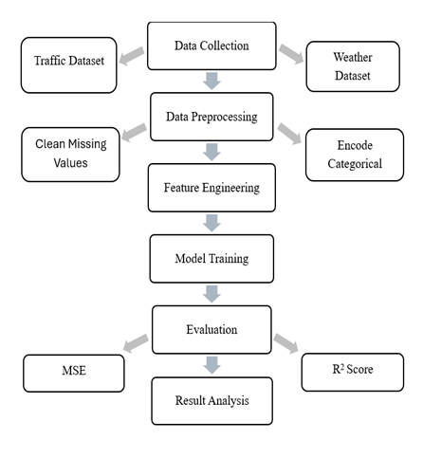
Figure 1: Methods for Traffic and Weather Data Analysis
Data Collection
The data was collected from Kaggle, which combines traffic dataset and weather dataset for better results [1], [5]. Vehicle traffic data is included in traffic dataset, while the weather dataset includes temperature, precipitation, humidity, wind speed, visibility, and cloud cover.
This helps the models learn the relationship between traffic and weather data. In the future, dynamic traffic prediction can be enabled by including real-time data through Application Programming Interfaces (APIs) [2].
Data Preprocessing
Data preprocessing is a mandatory procedure prior to the input of data into a machine learning algorithm to ensure accurate predictions. There are some unnecessary features that should be stripped away from the combined traffic and weather dataset. Missing values in the feature with critical values, such as number of vehicles and weather attributes, are imputed using statistics, particularly filling the gaps using means and medians.
In addition, numeric features, such as temperature, wind speed, and humidity, have to be standardized to avoid having a particular feature dominate over others due to large values. Categorical variables are also converted into appropriate numeric form. By this, machine learning models can be built, namely XGBoost, Random Forest Regression, and LSTM.
Training of Models
After‍‍‍‍‍‍ that, the preprocessed dataset is split into training and testing sets by 80:20. The machine learning models are trained using the training set (80%), and the performance of the models is evaluated on the testing set‍‍‍‍‍‍ (20%).
XGBoost Training
XGBoost,​‍​‌‍​‍‌​‍​‌‍​‍‌ an ensemble tree-based model, is utilized to model non-linear interactions between meteorological variables, traffic situations, and vehicle flow.The model's hyperparameters e.g. the number of estimators, learning rate, and maximum tree depth are adjusted to achieve the best prediction ​‍​‌‍​‍‌​‍​‌‍​‍‌accuracy.
Random Forest Regression Training
Random​‍​‌‍​‍‌​‍​‌‍​‍‌ Forest Regression, which is also an ensemble method, is trained in isolation. The various decision trees of its multiple sets combine the predictions to remove overfitting and increase generalization capability of the model thus enabling the model to learn complex patterns in traffic data ​‍​‌‍​‍‌​‍​‌‍​‍‌efficiently.
LSTM Training
LSTM​‍​‌‍​‍‌​‍​‌‍​‍‌ is a recurrent neural network that learns from the sequential data in order to capture the temporal dependencies in traffic flow. The model predicts the future vehicle counts by using the sequential past traffic and weather data. The parameters of the model such as the number of time steps, hidden layers, and neurons are changed to best capture the spatio-temporal ​‍​‌‍​‍‌​‍​‌‍​‍‌patterns.
Table​‍​‌‍​‍‌​‍​‌‍​‍‌ I shows the efficiency of the three machine learning models for traffic flow prediction. XGBoost was able to achieve the lowest MSE and the highest R² score, which is a clear indication of the best predictive accuracy. Random Forest Regression and LSTM were close to each other in terms of performance but their accuracy was lower than that of ​‍​‌‍​‍‌​‍​‌‍​‍‌XGBoost.
Table I : Performance comparison of XGBoost, Random Forest Regression, and LSTM for traffic flow prediction
Model | Mean Squared Error | R² Score
Random Forest Regression | 127.41943847242858 | 0.6827069576361373
XGBoost | 73.3193359375 | 0.8174241185188293
LSTM | 127.82922835849729 | 0.6816865208704486

Prediction and Scoring
After the training phase, the machine learning models are employed to predict the number of vehicles at each junction using temporal, weather, and locality-related input features. The predicted traffic volume at junction $j$ is given in equation (1):
$V_{j}=f_{θ}\left(X_{j}\right)$ (1)
where $f_{θ}(⋅)$ represents the trained machine learning model and $X_{j}$ denotes the feature vector consisting of hour of the day, weekday, meteorological conditions, and locality information corresponding to junction $j$.
Traffic volume is different at each junction, so values are normalized for consistent comparison. The traffic score $T_{j}$ is calculated using equation (2):
$T_{j}=\frac{V_{j}-V_{min}}{V_{max}-V_{min}}$ (2)
where $V_{min}$denote the minimum vehicle counts observed in the dataset and $V_{max}$ denote the maximum vehicle counts observed in the dataset. This ensures consistency in congestion comparison.
Traffic movement and road safety are affected by weather factors. The model estimates the impact of weather on driving. Let $P_{j}$ denote the precipitation type and $S_{j}$ denote the weather summary at junction $j$. This is defined in equation (3):
$w_{p}(P_{j})=\left\{\begin{matrix}0.4, & \text{if }P_{j}=\text{Rain} \\ 0.6, & \text{if }P_{j}=\text{Snow} \\ 0, & \text{otherwise}\end{matrix}\right.$ (3)
Visibility is affected by rain and snow can also create high risk due to low friction of tires. Other than rain, severe weather conditions such as fog, high wind, and clouds may also affect driving. This is expressed in equation (4):
$w_{s}(S_{j})=\left\{\begin{matrix}0.3, & \text{if }S_{j}∈S_{\text{severe}} \\ 0, & \text{otherwise}\end{matrix}\right.$ (4)
where $S_{\text{severe}}$ denotes the set of weather conditions that reduce visibility. The overall weather effect score $W_{j}$ is obtained in equation (5):
$W_{j}=w_{p}(P_{j})+w_{s}(S_{j})$ (5)
Other than traffic and weather conditions, the locality plays a major role. Rural areas have higher impact, whereas urban regions contribute less impact when compared to rural areas. The locality score is shown in equation (6):
$L_{j}=\left\{\begin{matrix}0.6, & \text{junction }\text{→}\text{ rural } \\ 0.4, & junction \text{→} urban\end{matrix}\right.$ (6)
The combined score $C_{j}$, which can be calculated by using traffic congestion, weather impact, and locality characteristics is defined in equation (7):
$C_{j}=L_{j}+T_{j}+W_{j}$ (7)
This combined score is used to make decision in travel. Higher values of $C_{j}$ indicate increased traffic whereas lower values indicate smoother traffic flow and safer travel conditions.
Travel can be classified based on the threshold by combined score using equation (8):
${\text{Travel Status}}_{j}=\left\{\begin{matrix}\text{Safe}, & C_{j}<τ_{s} \\ \text{Moderate}, & τ_{s}≤C_{j}<τ_{m} \\ \text{Unsafe}, & C_{j}≥τ_{m}\end{matrix}\right.$ (8)
The threshold values $τ_{s}=1.0$ and $τ_{m}=1.5$ are set based on normalized traffic scores. The safety limits are set based on observed traffic conditions, which help classify traffic conditions based on weather and suggest alternate routes.

Route Suggestion Logic
Alternate routes are suggested by considering various factors. For each possible route, the system looks at the combined effect of traffic predictions, weather conditions, and locality. To compare different routes fairly, traffic scores are normalized based on the predicted number of vehicles.
After the combined effects have been calculated, the system performs a comparison with the predefined thresholds.
• SAFE: combined effect < 1.0
• MODERATE: combined effect between 1.0 and 1.5
• UNSAFE: combined effect > 1.5
According to these thresholds, the system can be used to identify the junction as safe, to give the safe alternate route if there is one, or to advise waiting when no safe options are available. Therefore, commuters are assured of receiving actionable travel guidance that considers weather conditions and traffic.
RESULT ANALYSIS
We​‍​‌‍​‍‌​‍​‌‍​‍‌ have compared the effectiveness of three machine learning algorithms - XGBoost, Random Forest, and LSTM - in forecasting traffic volume during different weather conditions. The XGBoost model out of the three tested was the most effective, as it had the lowest MSE and the highest R² Score, which is a measure of how well the model predicts. Random Forest and LSTM models also delivered good results and were able to capture the non-linear relationships in the data but their accuracy was slightly lower. The results show that XGBoost works with complex traffic and weather data.
Fig. 2 shows that XGBoost predictions are closer to actual values when compared to LSTM and Random Forest
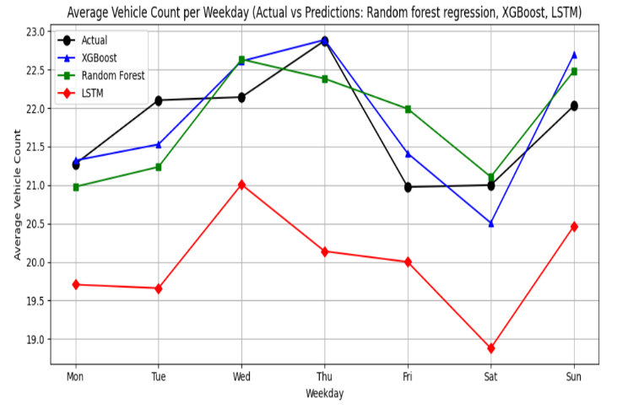
Figure 2: Comparison of Actual and Predicted Average Daily Vehicle Count using XGBoost, Random Forest, and LSTM
Fig. 3 illustrates the relationship between traffic and weather
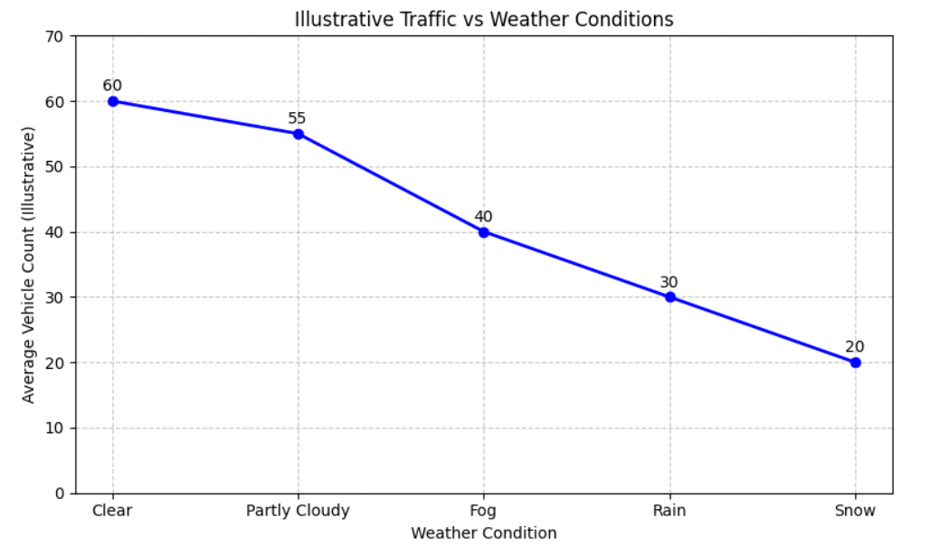
Figure 3: Illustrative Relationship Between Traffic Volume and Weather Conditions
Learning Curves
The​‍​‌‍​‍‌​‍​‌‍​‍‌ learning curves reveal the model performance of different training set sizes that were used to predict traffic volume under various weather conditions. The R² Scores as represented in Fig. 4 show that XGBoost is the one to achieve the maximum value of 0.817, which indicates a higher level of predictive accuracy. Fig. 5 illustrates the Mean Squared Error whereby XGBoost is seen to be the best performer at 73.32. The performance of Random Forest and LSTM is nearly the same, with R² scores of 0.682 and 0.681, and MSE values of 127.41 and 127.82, respectively. These results suggest that both Random Forest and LSTM are able to capture non-linear relationships, however, XGBoost is more capable of generalizing. Hence, the increase in the amount of data used for training leads to lower MSE and higher R², which is an indication of better model learning with more ​‍​‌‍​‍‌​‍​‌‍​‍‌data.
Fig. 4 illustrates the learning curve of the proposed model, highlighting the variation in R² score with respect to the training set size
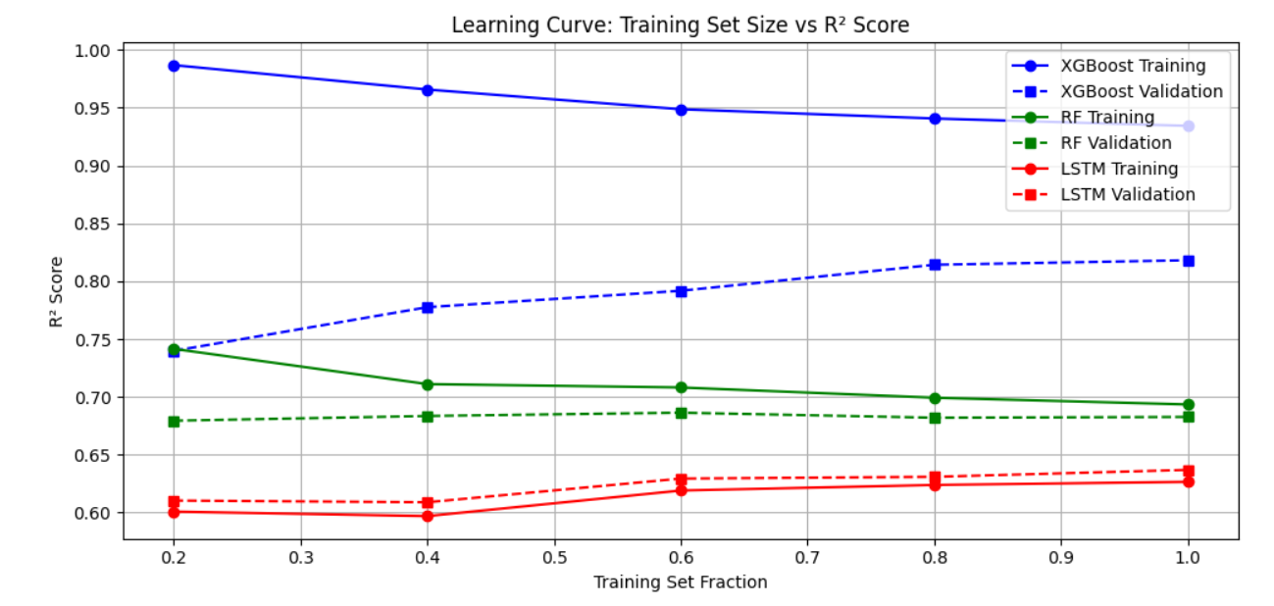
Figure 4: Learning Curve: Training Set Size vs R² Score
From Fig. 5, it can be observed that larger training datasets lead to a reduction in MSE, suggesting that the model benefits from additional data in minimizing prediction errors.
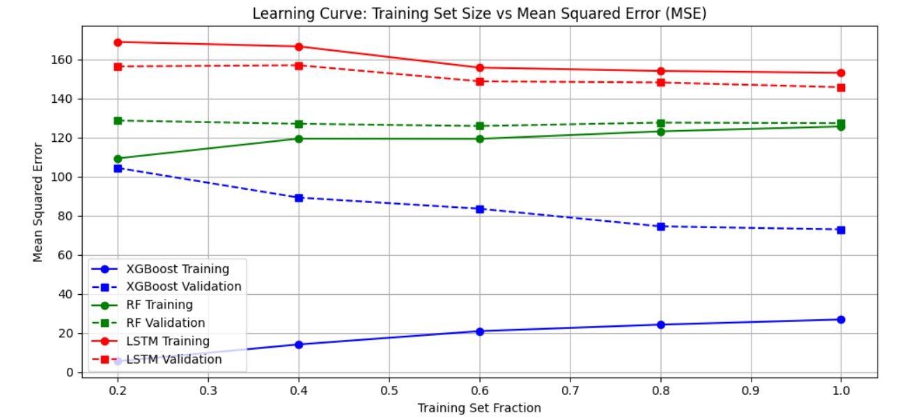
Figure 5: Learning Curve: Training Set Size vs Mean Squared Error (MSE)
Model Comparison
Mean Squared Error (MSE) Analysis
The​‍​‌‍​‍‌​‍​‌‍​‍‌ MSE quantifies the average of squared differences between the actual and predicted vehicle counts from the dataset. Essentially, lower MSE values point to the model’s predictions being in close proximity to the actual measurements, while, higher MSE values signify that there are larger discrepancies and lower levels of prediction accuracy. As a matter of fact, the graphical representation in Fig. 6 demonstrates that XGBoost has outperformed all other models in predicting with an MSE of only 73.32 whereas Random Forest and LSTM have scored 127.42 and 127.83, respectively. Further, the combined comparison in Fig. 7 amplifies the argument for XGBoost as it depicts this model’s MSE as the most optimal one when all models are taken ​‍​‌‍​‍‌​‍​‌‍​‍‌together
R² Score Analysis
The​‍​‌‍​‍‌​‍​‌‍​‍‌ R² Score, is a measure that reflects how much of the variance in the real data is explained by the model. The R² value closer to 1 indicates that the model has better predictive power and there is a stronger correlation between the predicted and observed data. This is supported by R² which is the main metric used to show the performance of XGBoost. XGBoost, therefore, is the model with the highest capability to predict the target variable. As shown in Fig. 6, the R² score for the XGBoost model is 0.817, significantly greater than those for the Random Forest (0.682) and LSTM models (0.681). Moreover, Fig. 7 by comparing the different models at a glance shows the performance of the models in general, thus it can be inferred that the models used can be generalized and are capable of predicting the traffic volumes accurately under different weather ​‍​‌‍​‍‌​‍​‌‍​‍‌conditions.
Fig. 6 compares the performance of XGBoost, Random Forest, and LSTM models in terms of MSE and R² scores.
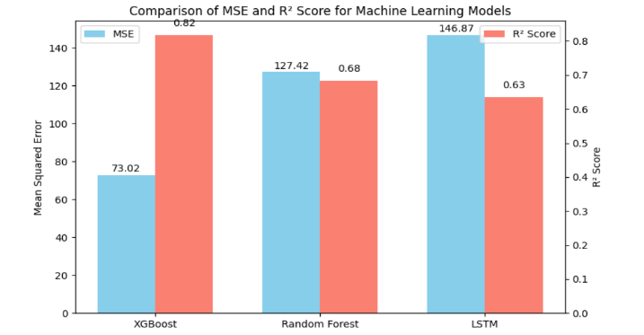
Figure 6: Comparison of MSE and R² Scores for Machine Learning Models
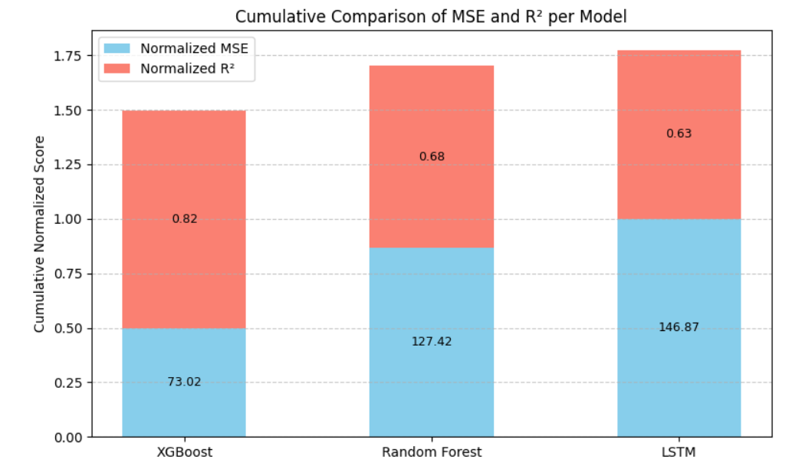
Figure 7: Cumulative Comparison of MSE and R² Scores for Machine Learning Models
CONCLUSION
With​‍​‌‍​‍‌​‍​‌‍​‍‌ an R² of 0.817 and an MSE of 73.32, the XGBoost model has been the most successful in making predictions and has outperformed the Random Forest (R²: 0.682, MSE: 127.42) and LSTM (R²: 0.681, MSE: 127.83) models. These models can be utilized for traffic flow prediction, consequently, they can be a great help in the planning of smart travel by giving accurate vehicle counts under different weather conditions. Employing these forecasting models, steps can be taken to lessen congestion, travel times can be optimized and road safety can be improved. The accuracy of the model can also be increased by adding more data like live weather and special events. Among all models, XGBoost gives better results, so it can be used for route suggestions.
Conflict of interest
The authors declare that there are no conflicts of interest regarding this study.
Consent for publication
The authors provide their consent for the publication of this chapter.
Acknowledgement
The authors would like to express their sincere gratitude to their guide for continuous support and valuable guidance throughout this work. We also thank our institution for providing the necessary resources to complete this research successfully.
REFERENCES
[1] Y. Hou, Z. Deng, and H. Cui, "Short-Term Traffic Flow Prediction with Weather Conditions: Based on Deep Learning Algorithms and Data Fusion," Complexity, vol. 2021, p. 6662959, Jan. 2021.
[2] W. Zhang, R. Yao, X. Du, Y. Liu, R. Wang, and L. Wang, "Traffic flow prediction under multiple adverse weather based on self-attention mechanism and deep learning models," Physica A: Statistical Mechanics and its Applications, vol. 625, p. 128988, Sep. 2023.
[3] Y. Qu, Z. Lin, H. Li, and X. Zhang, "Feature Recognition of Urban Road Traffic Accidents Based on GA-XGBoost in the Context of Big Data," IEEE Access, vol. 7, pp. 170106–170115, 2019.
[4] K. Cao, Y. Liu, L. Duan, S. Xu, and H. Jung, "Research on Regional Traffic Flow Prediction Based on MGCN-WOALSTM," IEEE Access, vol. 11, pp. 126436–126446, 2023.
[5] B. Sun, T. Sun, and P. Jiao, "Spatio‐Temporal Segmented Traffic Flow Prediction with ANPRS Data Based on Improved XGBoost," Journal of Advanced Transportation, vol. 2021, p. 5559562, 2021.
[6] B. Lartey, A. Homaifar, A. Girma, A. Karimoddini, and D. Opoku, "XGBoost: A Tree-Based Approach for Traffic Volume Prediction," in Proc. 2021 IEEE Int. Conf. Systems, Man, and Cybernetics (SMC), Melbourne, Australia, Oct. 2021, pp. 1280–1286.
[7] W. Zhang, R. Yao, X. Du, and J. Ye, "Hybrid Deep Spatio-Temporal Models for Traffic Flow Prediction on Holidays and Under Adverse Weather," IEEE Access, vol. 9, pp. 157165–157181, 2021.
[8] T. Lin and R. Lin, "Smart City Traffic Flow and Signal Optimization Using STGCN-LSTM and PPO Algorithms," IEEE Access, vol. 13, pp. 15062–15078, 2025.
[9] S. A. Kashinath et al., "Review of Data Fusion Methods for Real-Time and Multi-Sensor Traffic Flow Analysis," IEEE Access, vol. 9, pp. 51258–51276, 2021.
[10] J. Fior and L. Cagliero, "Correlating Extreme Weather Conditions with Road Traffic Safety: A Unified Latent Space Model," IEEE Access, vol. 10, pp. 73005–73018, 2022.
[11] S. Narmadha and V. Vijayakumar, "Spatio-Temporal Vehicle Traffic Flow Prediction Using Multivariate CNN and LSTM Model," Materials Today: Proceedings, vol. 81, pp. 826–833, Jan. 2023.
[12] P. Redhu and K. Kumar, "Short-Term Traffic Flow Prediction Based on Optimized Deep Learning Neural Network: PSO-Bi-LSTM," Physica A: Statistical Mechanics and its Applications, vol. 625, p. 129001, Sep. 2023.
[13] S. AlKheder and A. AlOmair, "Urban Traffic Prediction Using Meteorological Data with Fuzzy Logic, Long Short-Term Memory (LSTM), and Decision Trees (DTs)," Natural Hazards, vol. 111, no. 2, pp. 1685–1719, Mar. 2022.
[14] S. Das, S. Barua, and A. Hossain, "Unraveling the Complex Relationship Between Weather Conditions and Traffic Safety," Journal of Transportation Safety & Security, vol. 17, no. 5, pp. 572–611, May 2025.

Address correspondence to Dr. M. Ayyadurai: Department of Computer Science and Engineering, Rajalakshmi Engineering College, Chennai, India; Email: ayyadurai.m@rajalakshmi.edu.in; Phone: +91-7708911254
*Address correspondence to Dr. G. Dharani Devi: Department of Computer Science and Engineering, Rajalakshmi Engineering College, Chennai, India; Email: dharanidevi.g@rajalakshmi.edu.in; Phone: +91-9994121779

